HW for matlab

Yiheng Cao

Set 1

1.(b) code: N=1000

u=rand(1,N)

x=sqrt((-2)\*log(u))

c

m=sum(x)/N

v=sum((x-m).^2)/(N-1)

result: m =1.2640

v =0.4664

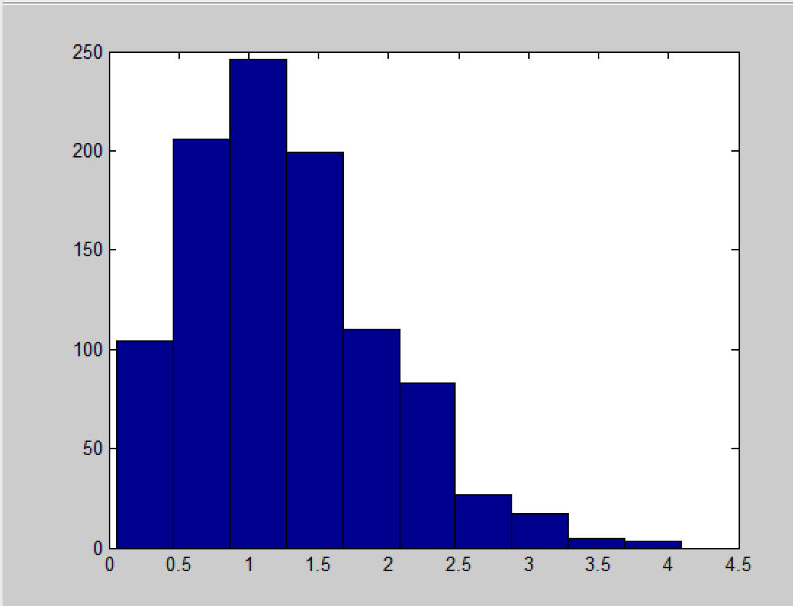

(c) σ^2= 0.5

result: m = 0.9022

v = 0.2020

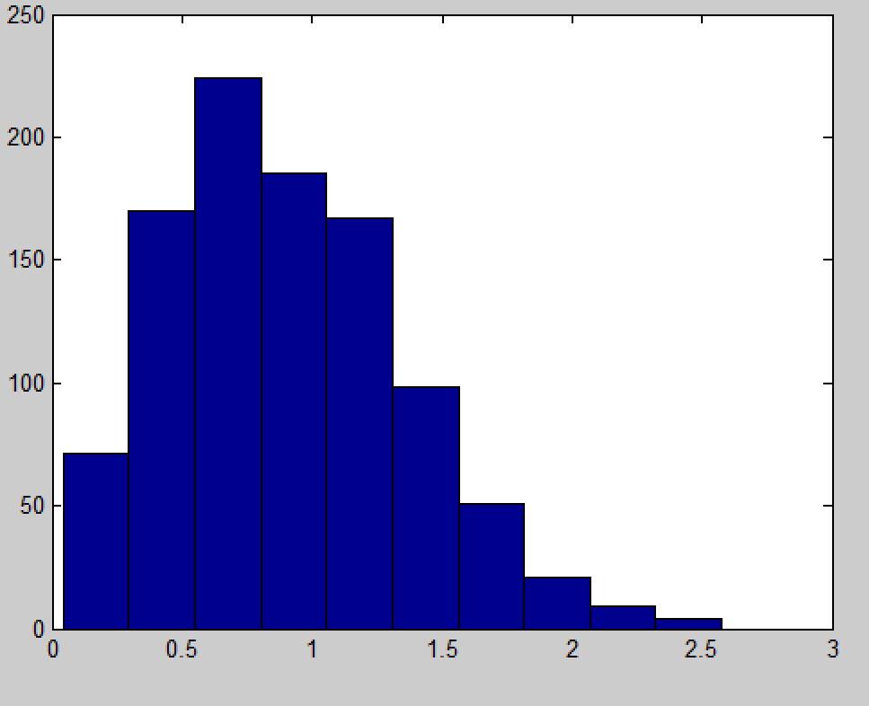

σ^2= 5

result: m = 2.7905

v = 2.1078

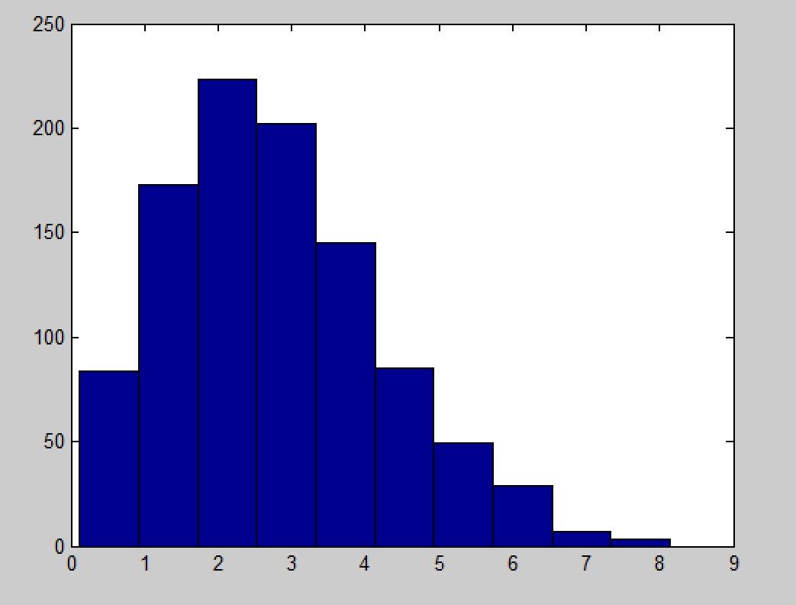

σ^2= 10

result: m = 4.0153

v = 4.5300

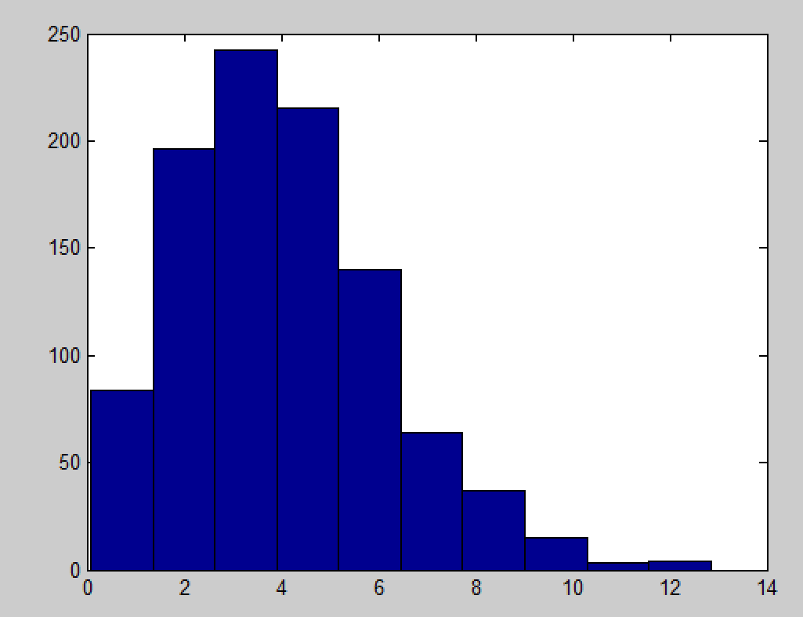

(d) When N is 1000, X is Rayleigh distribution. When the sigma becomes bigger, the mean and var become bigger, too.

2 (a) code: N=1000

u=rand(1,N)

x=(-1)\*log(u)

hist(x)

m=sum(x)/N

v=sum((x-m).^2)/(N-1)

result: λ= 1

m = 1.0789

v = 1.1549

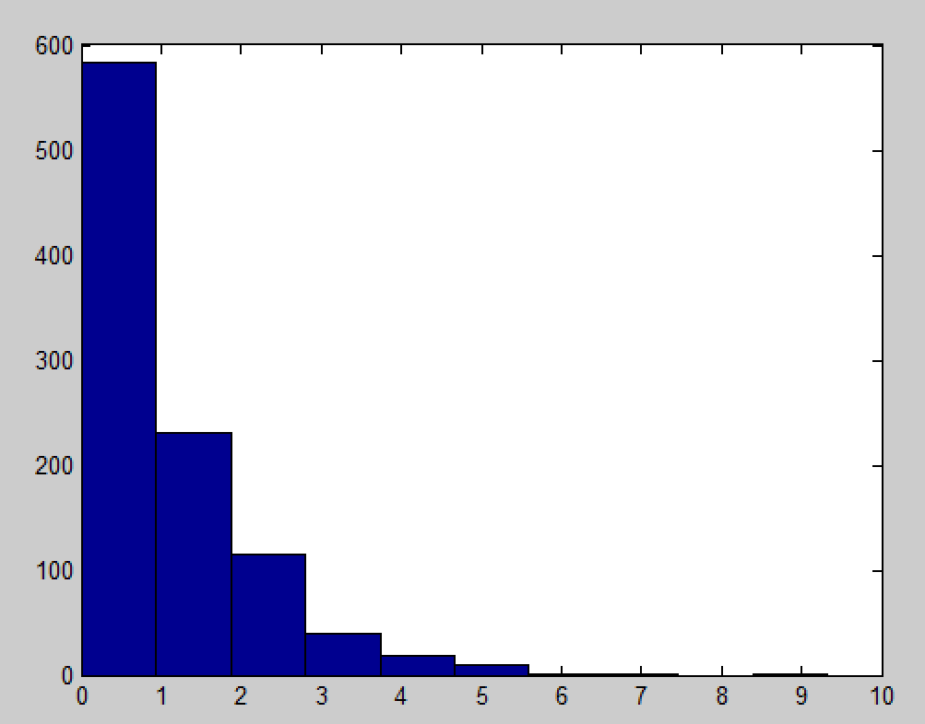

result: λ= 0.5

m = 0.4928

v = 0.2565

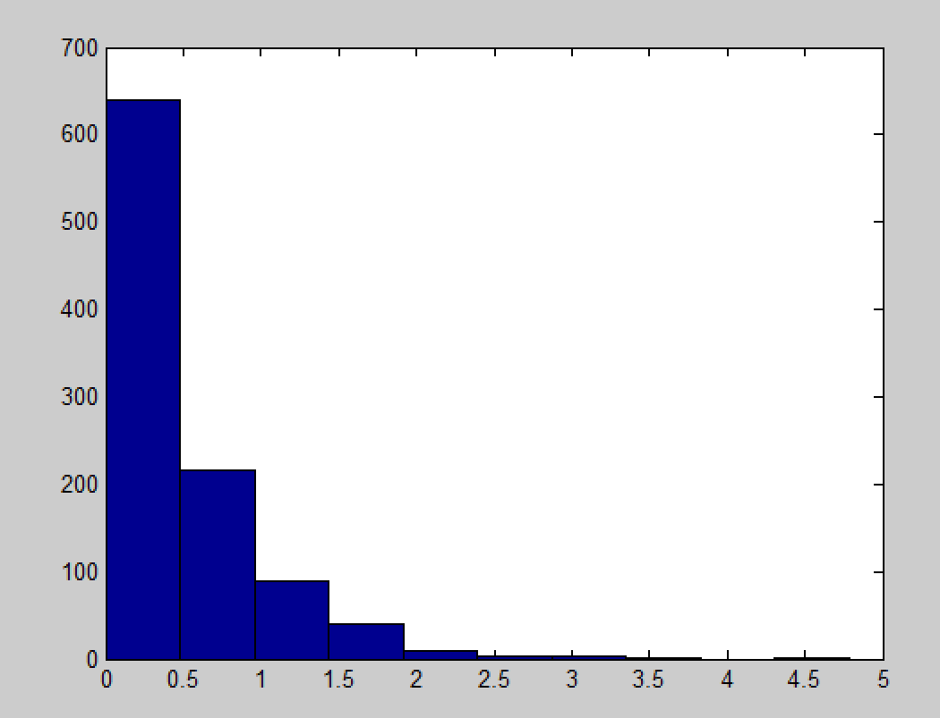

result: λ= 5

m = 4.8263

v = 25.3759

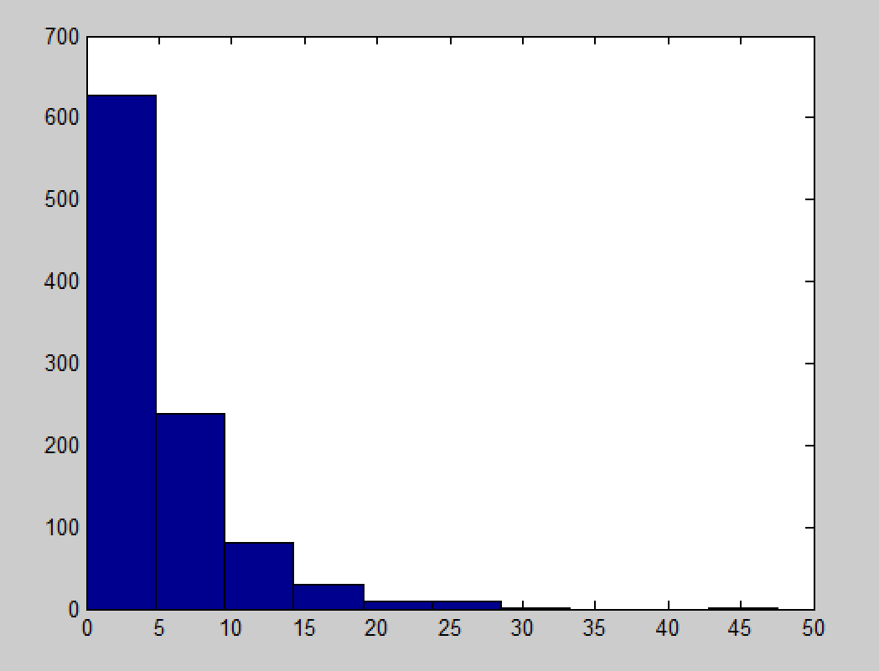

(d) When N is 1000, X is exponential distribution. When theλbecomes bigger, the mean and var become bigger, too

Set 2s

(a)code: N=100

L=1000

x = zeros(1,L)

for k = 1:L

xi=random('rayl',1,[1,N])

x(k)= sum(xi)/N;

end;

hist(x)

mean(x)

var(x)

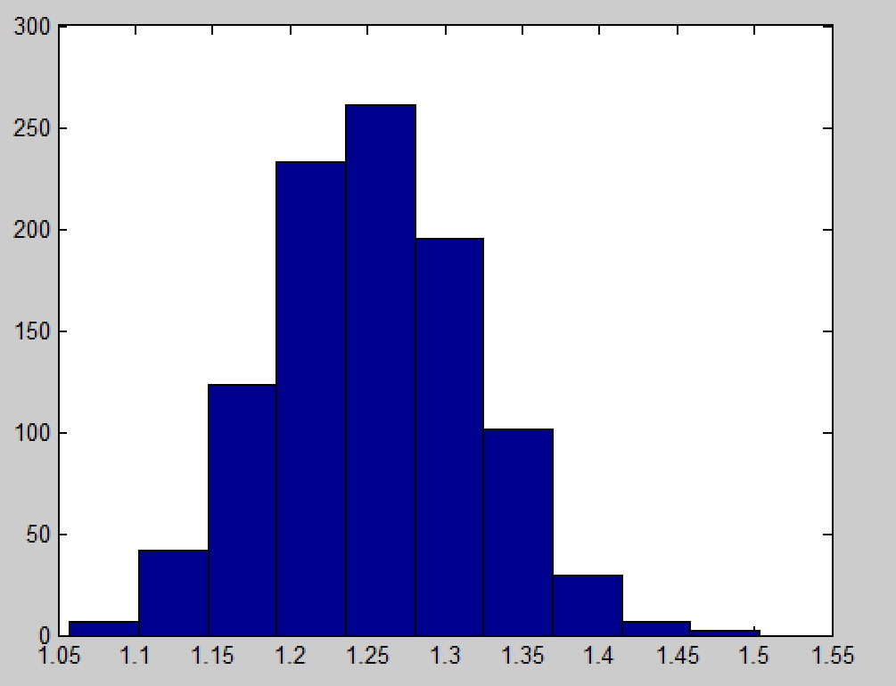

Yes, Gaussian with mean=1.2537 and var=0.0043

(b) 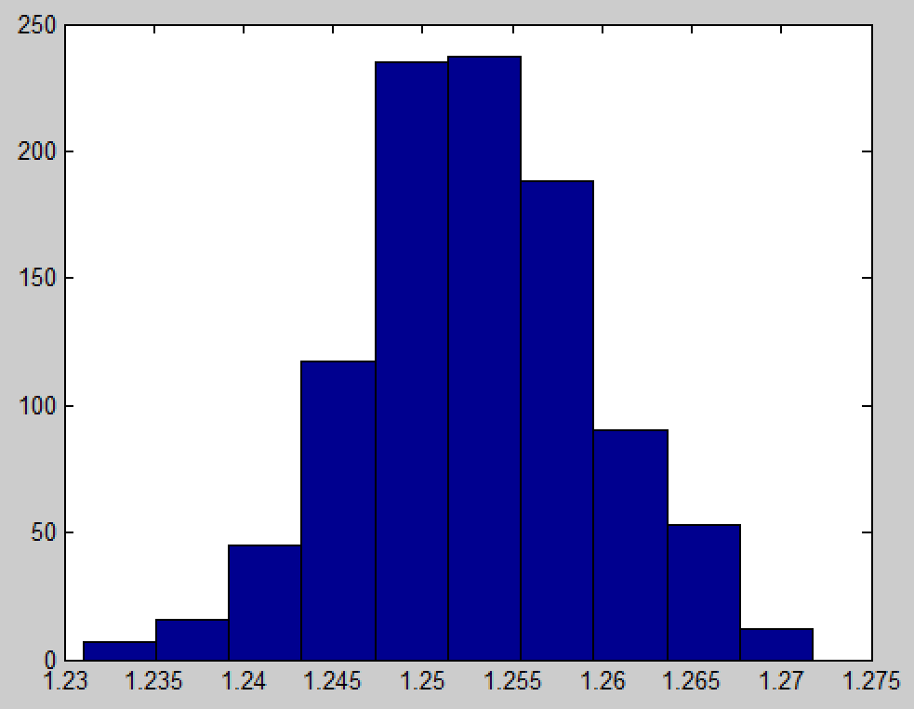

Yes, Gaussian with mean= 1.2530 and var= 4.4337e-05

(c) code: n=100

l=1000

x = zeros(1,l)

for k = 1:l

xi=random('exp',1,[1,n])

x(k)= sum(xi)/n;

end;

hist(x)

mean(x)

var(x)

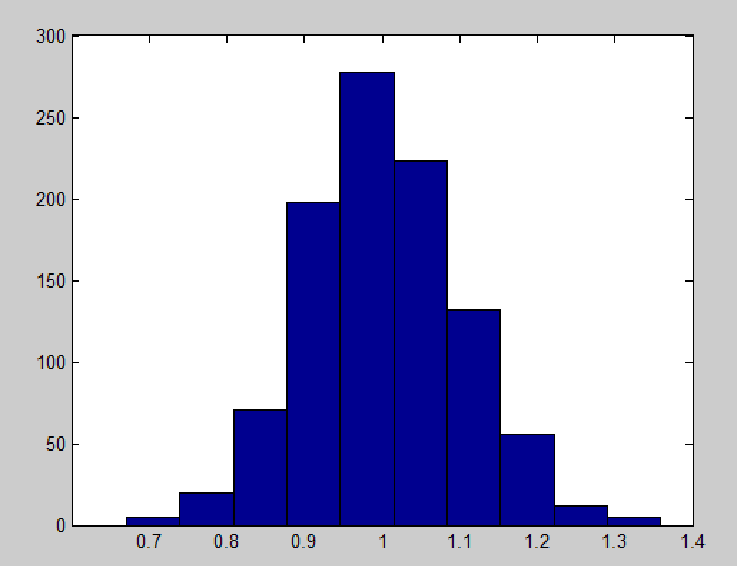

Yes, Gaussian with mean= 1.0011 and var= 0.0101

(d) 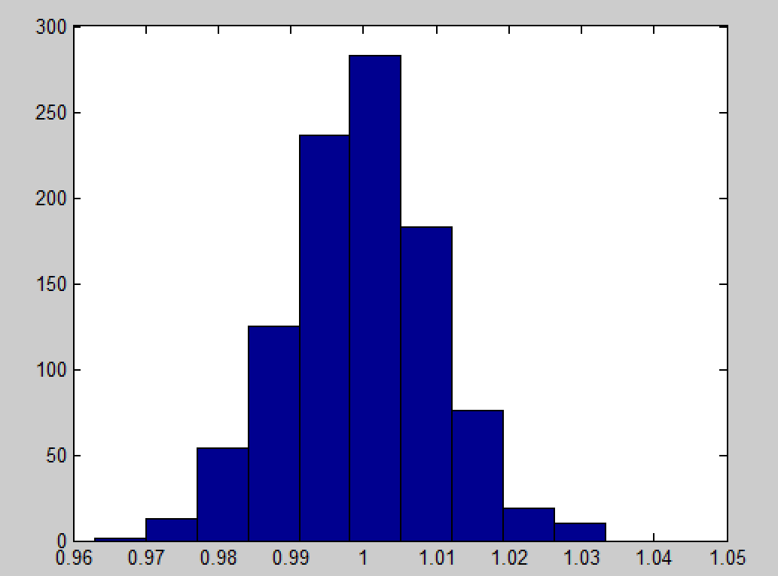

Yes, Gaussian with mean= 0.9997 and var= 1.0368e-04

(e)code: n=100

l=1000

x = zeros(1,l)

for k = 1:l

xi=random('rayl',1,[1,n])

yi=random('exp',1,[1,n])

x(k)= sum(xi)/sum(yi);

end;

hist(x)

mean(x)

var(x)

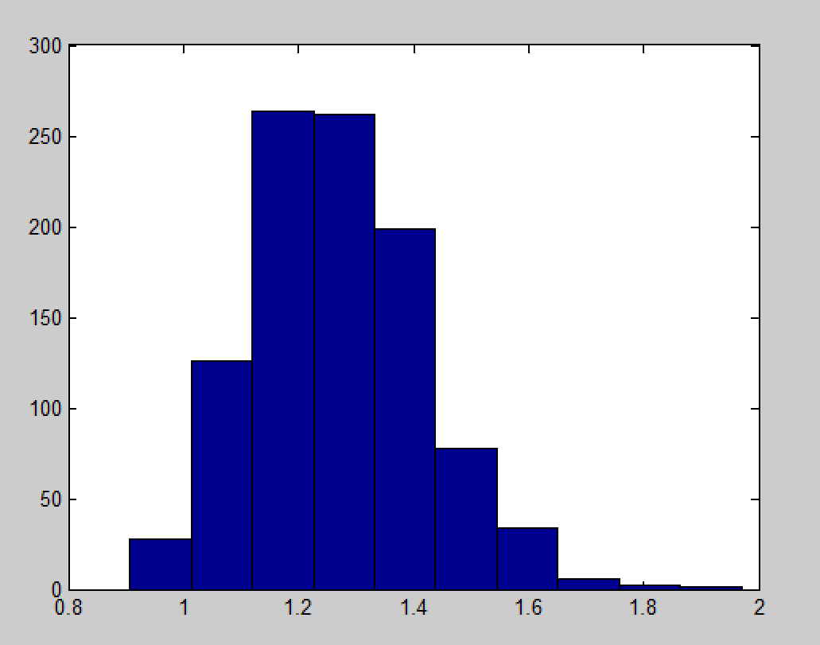

Mean= 1.2676

(f) 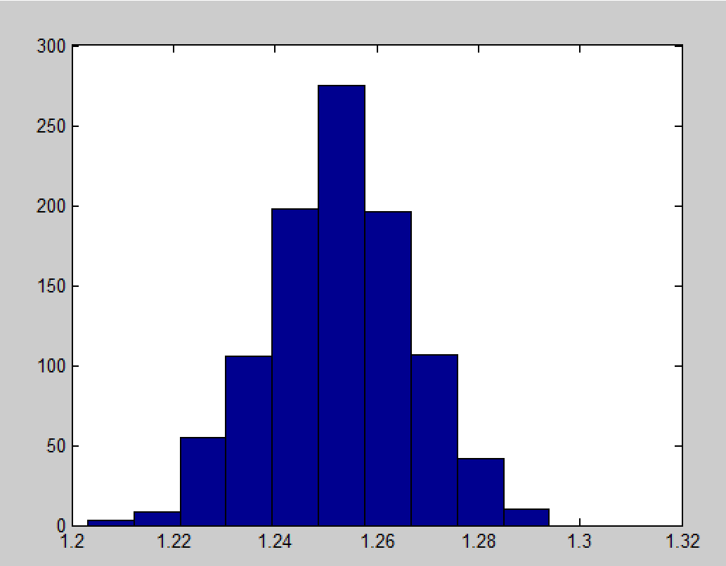

Mean=1.2527

(g) Z is Gaussian when N becomes bigger.